Unit- V

APPLICATION ICs

PART-A

1.Define Load regulation and Line regulation.(Apr/May-19) (May/Jun 16)

Load regulation is defined as the change in regulated output voltage for a change in load current. It is usually expressed in millivolts or as a percentage of V₀.
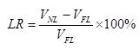

Where,

VNL → Load voltage with no load current VFL → Load voltage with full load current
Line regulation is defined as the percentage change in the output voltage for a change in the input voltage. It is usually expressed in millivolts or as percentage
of the input voltage.
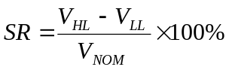
Where, V_{HL} → Load voltage with high line voltage
V_{LL} → Load voltage with low line voltage
V_{NOM} → Nominal Load voltage

- State the need for protection diodes in voltage regulators based on LM317 regulator? (May/June-14)
To avoid the discharging of the capacitors through low current points in to the regulator, the protecting diodes are used in LM317.

- Name the various protection circuit used for voltage regulator. (Nov/Dec-12)

  - Constant current limiting

  - Fold back current limiting

  - Over voltage protection

Thermal protection

4.What is an isolation Amplifier?(No/Dec-17) (Nov/Dec-18)(Apr/May -18)

Isolation amplifier which provides electrical isolation between i/p and o/p.the i/p and o/p optically connects and electrically isolated. It is used in medical instruments optical isolation done by LED and photo detector.
- List the features of opto coupler. (No/Dec-17) (Apr/May-18)

  - 1.Collector emitter voltage

  - 2.forward current

  - 3.Collector dark current

  - 4.Isolation resistance

  - 5.Response time

- Draw the pin diagram of IC 723 regulator. (Nov/Dec -19)
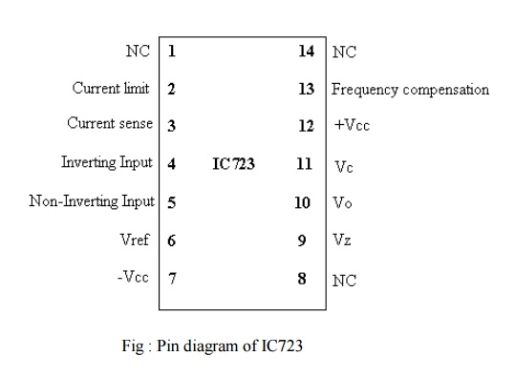
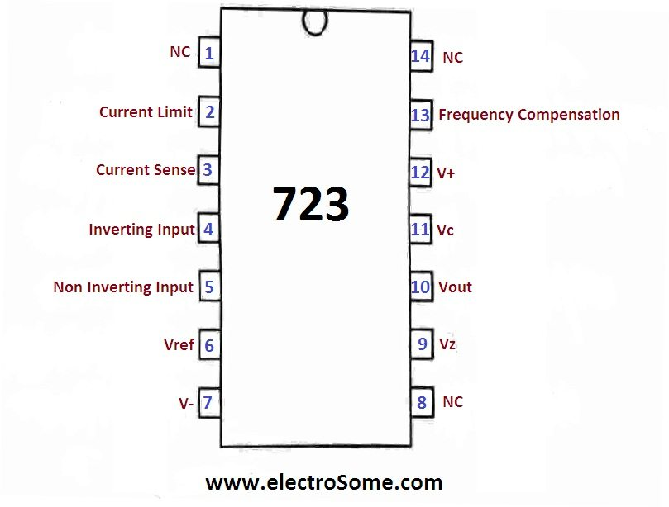
- What are the disadvantages of linear voltage regulator?

  - The required input step down transformer is bulky and expensive.

  - Due to low line frequency (50Hz), large values of filters capacitors are required.

  - The efficiency is very low.

  - Input must be greater than the output voltage.

- Why current boosting is done in IC 723 regulators? (April/May-11)

The IC 723 general purpose regulator can 150mA. For supplying the load which demands current boosting is done in IC 723.
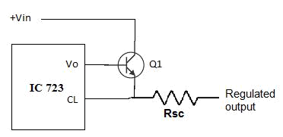

deliver maximum output current of the current more than 150 mA, the

9. Using LM380 draw the circuit for audio power amplifier. (Nov/Dec-10)
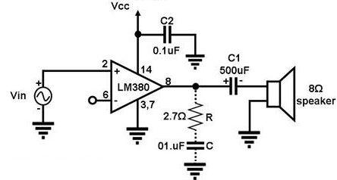

10. What is a voltage regulator? Write the classifications?

A voltage regulator is an electronic circuit that provides a stable dc voltage independent of the load current, temperature, and ac line voltage variations.

  - Series / Linear regulators

  - Switching regulators.

- Define the term settling time

Settling time is the time elapsed from the application of an ideal instantaneous step input to the time at which amplifier output has entered and remained within a specified error
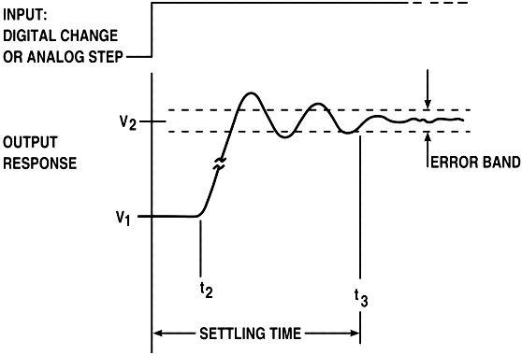

- How current boosting achieved in a 723 IC?(Nov/Dec -18) (April/May-15)

The maximum load current of IC 723 is 150 mA. If the current is to be boosted than external transistor Q1 is connected to output terminal as shown in figure.

13.What is a switching regulator? Write its advantages? (Apr/May-17)

Regulator which operate the transistor as a high frequency ON/OFF switch, so that the power transistor does not conduct current continuously is called switching regulator or switched mode regulator.

Advantages

- Greater efficiency is achieved as the power transistor is made to operate as low impedance Switch.

- The transistor power dissipation is very low as it is operated as switch

- By using suitable switching loss reduction technique, the switching frequency can be increased so as to reduce the size and weight of the inductors and capacitors.
- Low ripple current

- Simple to design

14.What is the principle of switched mode power supply? (Nov/Dec-19,16)

The switching regulators also called as switched mode regulators. Such a switching regulators requires external transistor and choke. The series pass transistor in such a regulator is used as a controlled switch is operated in cut off region or saturation region. Hence power transmitted across such a transistor is in the form of discrete pulses rather than the steady flow of current.

15. What is the function of voltage regulator? (May/Jun16)

A voltage regulator circuit is used after the filter in the DC supply and it maintains the output DC voltage constant under the variable load as well as variable input conditions.

16. What are the advantages of SMPS? (April/May-10)

    - A Switch mode power supply works on the principle of superior efficiency. The benefit of the switch mode is its lighter weight and reduced size. Saving weight and reducing size is crucial to lower shipping costs when they are distributed improving.

    - The Switch Mode Power is designed to be a more efficient Unit running much cooler and draws less current which is beneficial all round.

    - Older designed transformers had to be large to avoid saturation at the 50Hz or 60Hz frequency of the AC supply. That issue resulted in poor performance at that lower frequency range..

    - The switch mode power supply amplifier wastes very little power in the form of heat. Most of the incoming AC power is converted to amplifier output power.

- What are the limitations of three terminal regulators? (Nov/Dec 19)

For fixed voltage regulators the output is not very precise.

Only selected values of output voltages are available.

Current boosting with the help of series pass transistor is necessary if load demand more current than that of the basic capability of regulator.

- How power amplifiers are classified? Mention power amplifier IC. (April/May-15)

  - Class A where output exists for 360° for 360° of input.

  - Class B where output exists for 180° for 360° of input.

  - Class C where output exists for less than 180° for 360° of input.

  - Class AB where output exists for more than 180° but less than 360° for 360° of input.

POWER AMPLIFIER IC

The various power amplifier ICs are LM 380, LM 384 and IC 810.

- List the few applications of fixed voltage regulator.(Nov/Dec -19)

- Low current consumption
- Overvoltage/ Short-circuit protection
- Reverse polarity protection
- Over temperature protection
- Load protection

- What is a series (or)linear voltage regulator?(Nov/Dec -18) (Apl/May-17)

Series or linear regulator uses a power transistor connected in series between the unregulated dc input and the load and it conducts in the linear region .The output voltage is controlled by the continous voltage drop taking place across the series pass transistor.
21. What is a switched capacitor filter?

A switched capacitor filter is a three terminal element, which consists of capacitors, periodic switches and operational amplifiers and whose open circuit voltage transfer function represents filtering characteristics. The operation of the

filter is based on the ability of on-chip capacitors and MOS switches to stimulate resistors.

22. What is frequency to voltage converter?

A converter which generates an output voltage (V_{O}) that is linearly proportional to the frequency of the input waveform (f_{I}) is called frequency to voltage converter.

V_{O} = k. f _{I}

Where k is the FVC sensitivity, in volts per hertz.

23. Define current transfer ratio (CTR).

The current transfer ratio (CTR) refers to the ratio of the output collector current (I_{c)} to the output forward current (I_{F)}.Current transfer ratio,

CTR = ^{I} ^{C} ×100%
I _{F}

24. Give some examples of monolithic IC voltage regulators:

  - 78XX series fixed output, positive voltage regulators

  - 79XX series fixed output, negative voltage regulators

  - 723 general purpose regulator.

25.Give the drawbacks of linear regulators:

- The input step down transformer is bulky and expensive because of low line frequency.

- Because of low line frequency, large values of filter capacitors are required to decrease the ripple.

26.What is the advantage of switching regulators?

- Greater efficiency is achieved as the power transistor is made to operate as low impedance switch. Power transmitted across the transistor is in discrete pulses rather than as a steady current flow.

- By using suitable switching loss reduction technique, the switching frequency can be increased so as to reduce the size and weight of the inductors and capacitors.
27.What are the applications of fixed voltage regulator?(Nov/Dec-16)

- AV devices

- RF,Radio communication devices

- Medical equipment

- Measurement devices

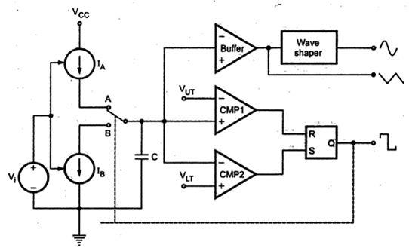
- Draw the internal block diagram of a function generator IC. (Nov/Dec-14)

29.Draw the pin diagram of IC 8038. (Nov/Dec-14)
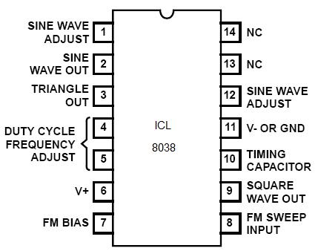
PART-B

1.Write short notes on Series voltage regulator.(April/May-19),(Nov/Dec-18)

A Voltage regulator is an electronic circuit that provides a stable d.c voltage independent of the load current, temperature and a.c line voltage variations.

- The series regulator circuit consists of following four parts:

  - Reference voltage circuit

  - Error amplifier

  - Series Pass transistor

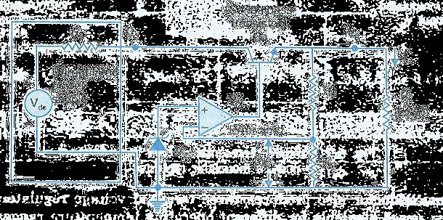
  - Feedback network

- The power transistor Q₁ is in series with the unregulated d.c voltage V_{in} and the regulated output voltage V_{O.} So it must absorb the difference between these two voltages whenever there is any fluctuation in output voltage V_{O} occurs.

- The transistor Q₁ is also connected as an emitter follower and therefore provides

sufficient current gain to drive the load. The output voltage is sampled by the divider and feedback to (-) input terminal of the op-amp error amplifier.

- This sampled voltage is compared with the reference voltage V_{ref}. The output V_{O}′ of

the error amplifier drives the series transistor Q₁. If the output voltage increases ,say, due to variation in load current, the sampled voltage βV_{O} also increases, where,
_{β} ₌ ^{R}2

R₁ + R₂

- This, in turn, reduces the output voltage V_{O}′ of the diff- amplifier due to 180º phase difference provided by Op-Amp.

- V_{O}′ is applied to the base of Q₁, which is used as an emitter follower. So V_{O} followsV_{O}′ , that is V_{O} also reduces. Hence the increase in V_{O} is nullified. Similarly, reduction in output voltage also gets regulated.

2.Explain the principle of operation IC LM 317 as a voltage regulator.

(April/May-17)(Nov/Dec-14)

The fixed voltage regulators, IC voltage regulators are available which allow the adjustment of the output voltage. The output voltage can be adjusted from 1.2 V to as high as 57 V with the help of such regulators. In such regulator ICs the common terminal plays the role of control input and hence called ADJUSTMENT (ADJ)
terminal. The LM317 series is the most commonly used three terminal adjustable regulators. These devices are available in a variety of packages which can be easily mounted and handled. The power rating of such regulators is 1.5 A. the maximum input voltage of LM317 is 40 V.
The table shows the various type of adjustable regulators and the corresponding output range and maximum output current rating.

Three terminal adjustable regulators

Type | Output voltage | Output current
LM 317 | + 1.2 to 57 V | 1.5 A
LM 337 | + 1.2 to - 47 V | 1.5 A
LM 358 | + 1.2 to 32 V | 5 A
LM 350 | + 1.2 to 32 V | 3 A
LM 396 | + 1.2 to 15 V | 10 A

Adjustable voltage regulators have the following advantages over fixed voltage regulators,
- Improved line and load regulation by a factor of 10 or more.

- Because of improved overload protection, greater load current can be drawn over the given operating temperature range.

- Improved reliability for the power supply using these regulators.

Thus, Adjustable voltage regulators have become more popular because of their versatility, performance and reliability. The LM317 is the most widely used adjustable voltage regulator series.

CONNECTION DIAGRAM OF LM317 REGUATOR

The LM 317 requires only two external resistances R1 and R2, to set the required output voltage. Internally it develops a reference voltage of 1.25 V between OUT and ADJ terminals, which is denoted as Vref. This voltage impressed across the resistance R1. So for constant Vref and R1. The current I_{R1} is also constant. So the resistance R1which sets the current I_{R1} is called current set resistor or program resistor.

The current I_{ADJ} flows out from the ADJ terminal and is similar to the quiescent current I_{Q} in the fixed voltage regulator. This current, along with I_{R1} flow through the resistance R2. The design of LM317 is such that the current I_{ADJ} is very small and remains constant with line and load changes. The maximum value of I_{ADJ} is 100 µA which is very small.
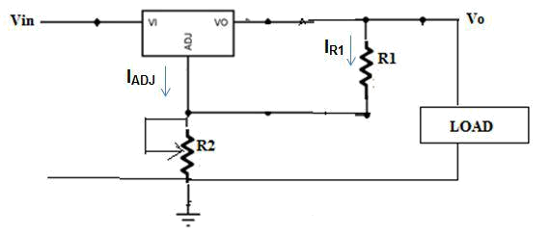

Fig: The schematic diagram of LM317

By KVL, we can write,

Vo = VR1 = VR2

V_{O} = I_{R1} R₁ + (I_{R1}+ I_{ADJ}) R₂

I_{R1} = (V_{REF}/R₁) = (1.25/R₁)

V_{O} = 1.25 + (1.25/R₁)*R₂ + I_{ADJ} R₂

V_{O} = 1.25 (R₁+R₂) / R₁ + I_{ADJ} R₂

The current I_{ADJ} is very small and hence the drop I_{ADJ} R₂ is also very small and can be neglected.

V_{O} = 1.25 * 1+(R₂+R₁)

Thus the output voltage is a function of R1 and R2. Keeping R1 fixed and varying R2, the output voltage can be adjusted. The program resistor R1 is generally 240 Ω.Generally no capacitors are required.

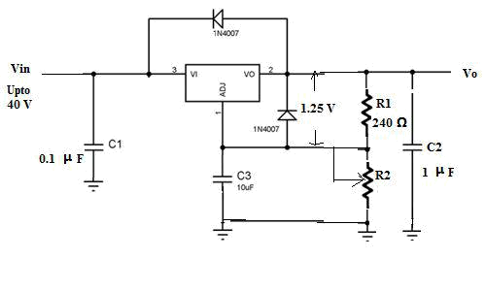
But if LM317 is located far from the power supply filter than the capacitors C1 is generally 0.1µF tantalum while the output capacitor C2 is in the range of 1 to 1000 µF. to get high ripple rejection, the capacitor C3 is used. To avoid the discharging of the capacitors through low current points into the regulator, the protecting diodes are used.

Fig: Functional diagram of LM317

3.Explain the working of video amplifier.

- A video amplifier has to amplify signal over a wide band of frequency, say D.C to up to few MHz. The shape and form of the video waveform must be persevered during amplification.

- The shape of the complex waveform depends not only on the frequency contained in the signal but also upon the relative phases. Therefore it is necessary that
  - All the frequencies must be amplified equally to maintain the same relative amplitudes.

  - The relative phases of all the frequency components in the output must be same as that of that input.

- Hence video amplifier is essentially a wide band amplifier with band width from D.C to high frequency up to few MHz .Many IC video amplifiers, like μA733, CA3040, LM733 etc use differential amplifier as inputs and outputs. So that they can accept both singled ended and balanced input signal and produces both single ended and balanced output signal.

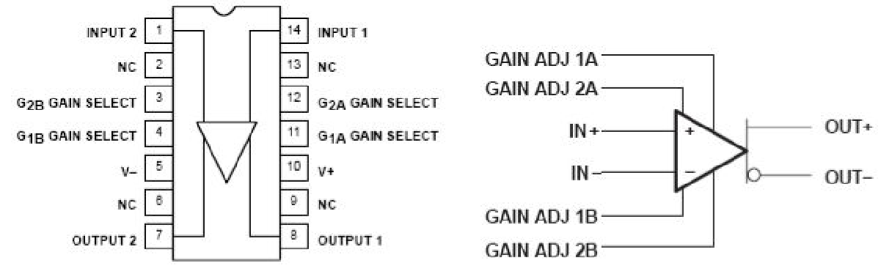

FEATURES:

- 200 MHz Bandwidth

- 250 KΩ input resistance.

- Selectable nominal amplification of 10,100 or 400.

DESCRIPTION:
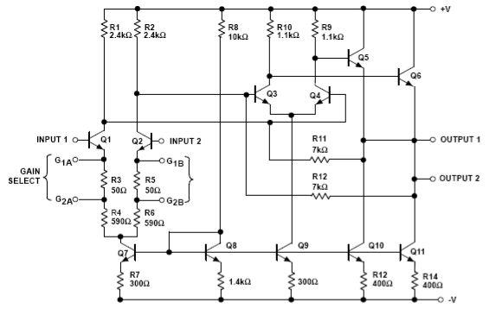

- The μA733 is a monolithic two stage video amplifier with differential inputs and differential Outputs. Internal series-shunt feedback provides wide bandwidth, low phase distortion and excellent gain stability. Differential amplifier with transistor Q₁and Q₂ forms the Input stage and it is biased by transistor Q₇ and R₁,R₂ are load resistors.

- Second stage is also a differential amplifier with Q₃and Q₄ here biasing is provided by transistor Q_{9,} and transistors Q₅, Q₆ are emitter follower stages with current sink transistors Q₁₀ and Q₁₁. This provides the necessary impedance matching between the second differential amplifier stage and load.

- All the stages are current source biased to obtain high CMRR and SVRR. Fixed differential amplification of 10V/V, 100V/V, and 400V/V may be selected without any external components.

- The amplification may be adjusted from 10V/V, to 400V/V by the use of single external resistor connected between 1A and 1B or 2A and 2B.

- No external frequency compensating components are required for any gain option.
FREQUENCY RESPONSE:
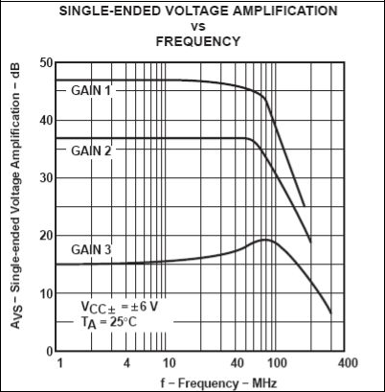

- As about 100MHz, the gain 3 curve peaks a little. This is because, at this frequency, there is 180 phase shift in the feedback which makes the negative feedback become positive feedback.

APPLICATIONS:

- Application includes general purpose video and pulse amplifier, where wide bandwidth, low phase shift excellent gain is required.
- Broadband communication, Telephony, Thin and thick film memories and video recorder systems.

4. With circuit diagram explain the working principle of IC 723 voltage regulator?

(Nov/Dec19)(May/June-16

- The IC 723 general purpose regulator can be adjusted over a wide range of both positive and negative regulated voltage. This IC is a low current device, but can be boosted to provide 5 amps or more current by connecting external components.
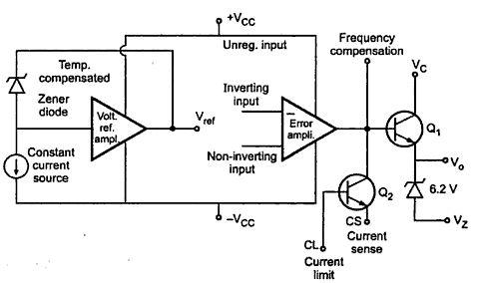

Fig : Functional block diagram

- The functional block diagram consists of two separate sections. The first section

contains a zener diode, a constant current source and reference amplifier to produce a fixed voltage of 7 volts at the terminal V_{ref.}

- The constant current source forces the zener to operate at a fixed point so that the zener outputs a fixed voltage. The other section of the IC consists of an error amplifier, a series pass transistor Q1 and a current limit transistor Q2.
- The error amplifier compares a sample of the output voltage applied at the INV input terminal to the reference voltage V_{ref} applied at the NI input terminal.

- The error signal controls the conduction of Q₁.These two sections is not internally connected but the various points are brought out on the IC package. IC 723 is available in 14-pin Dual-in line package or 10-pin metal can package.
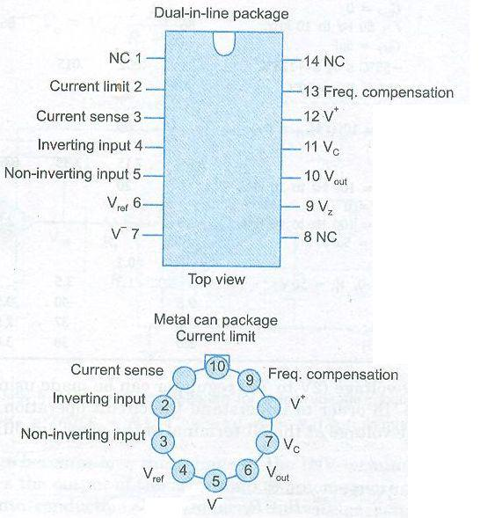

- The voltage at the NI terminal of the error amplifier due to R₁-R₂ divider is,

^{V} NI ⁼ ^{V}ref |  | R₂ |  | --------------------- (1)
^{V} NI ⁼ ^{V}ref | R | + R | 2 | --------------------- (1)
1 |  |  | 2

- The difference between V_{NI} and the output voltage V_{O} which is directly fed back to the INV terminal is amplified by the error amplifier.
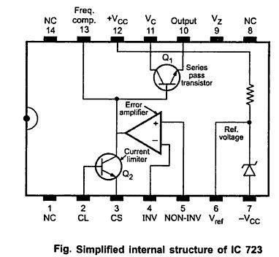

- The output of the error amplifier drives the pass transistor Q₁ so as to minimize the difference between the NI and INV inputs of error amplifier. Since Q₁ is operating as an emitter follower,
^{V} O⁼ ^{V}ref |  | R₂ |  |  | --------------------- (2)
^{V} O⁼ ^{V}ref | R | + R | 2 |  | --------------------- (2)
 | 1 |  | 2

- If the output voltage becomes low, the voltage at the INV terminal of error amplifier

also goes down. This makes the output of the error amplifier to become more positive, thereby driving the transistor Q₁ more into conduction.

- This reduces the voltage across Q₁ and drives more current into the load causing voltage across load to increase. So the initial drop in the load voltage has been compensated.

- Similarly any increase in load voltage, or changes in the input voltage get regulated. The reference voltage is typically 7.15V. So the output voltage V_{O} is,

V _{O}= 7.15 × | ^{R}2 |  | -------------------- (3)
V _{O}= 7.15 × | R₁ + R₂ |  | -------------------- (3)

Thus the above circuit is used as a Low Voltage regulator (< 7V).
- Explain the working of a Switched mode power supply (SMPS) (or) Switched mode regulator with neat diagram. (April/May-19, 17),(Nov/Dec-18,17)

- In series regulator, the pass transistor is operated in its linear region to provide a controlled voltage drop across it with a steady DC current flow.

- Whereas, in the case of switched-mode regulator, the pass transistor is used as a “controlled switch” and is operated at either cutoff or saturated state.

- Hence the power transmitted across the pass device is in discrete pulse rather than as a steady current flow.

- When the pass device is at cutoff, there is no current and dissipates no power. When the pass device is in saturation, a negligible voltage drop appears across it and thus dissipates only a small amount of average power, providing maximum current to the load.

- In either case, the power wasted in the pass device is very little and almost all the

power is transmitted to the load. Thus efficiency in switched mode power supply

is remarkably high- in the range of 70-90%.

- Switched mode regulators rely on Pulse Width Modulation to control the average value of the output voltage. The average value of a repetitive pulse waveform depends on the area under the waveform. If the duty cycle is varied .

- The bridge rectifier and capacitor filters are connected directly to the a.c line to give unregulated dc input. The thermistor R_{t} limits the high initial capacitor charge current.

- The reference regulator is a series pass regulator of the type shown in the Fig. Its output is a regulated reference voltage V_{ref} which serves as a power supply voltage for all other circuits.
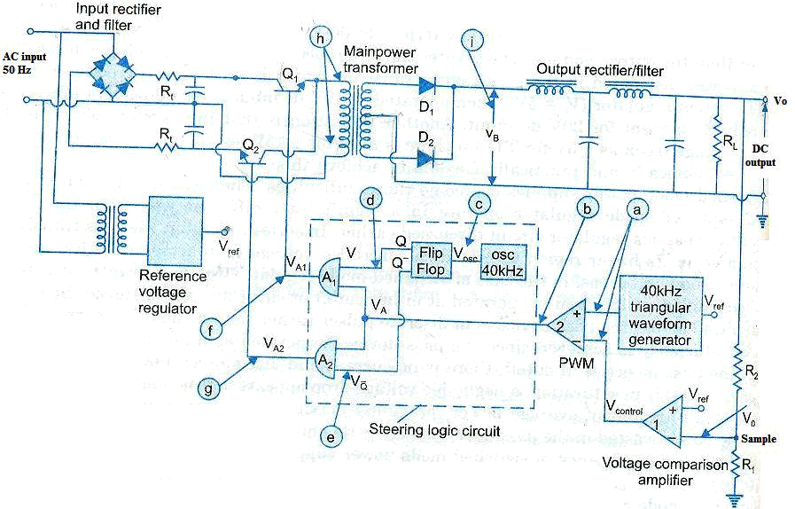

Fig : Switched mode power supply

- Transistors Q₁and Q₂ is alternately switched OFF and ON at 20kHz.These transistors are either fully ON (V_{CE (sat)} ~0.2 V) or cut-off, so they dissipate very little power. These transistors drive the primary of the main transformer.

- The secondary is center-tapped and full wave rectification is achieved by diodes D₁and D₂.This unidirectional square wave is next filtered through a two stage LC filter to produce output voltage V_{O}.

- The feedback circuit of a Pulse-Width Modulator and Steering Logic Circuit achieves the regulation of V_{O}. The output voltage V_{O} is sampled by a R₁-R₂ divider and a fraction R₁/(R₁+R₂) is compared with a fixed reference voltage V_{ref} in comparator1.

- The output of this voltage comparison amplifier is called V_{control} and it is applied to the (-) input terminal of comparator 2 and a triangular waveform of frequency 40 kHz is applied at the (+) input terminal.
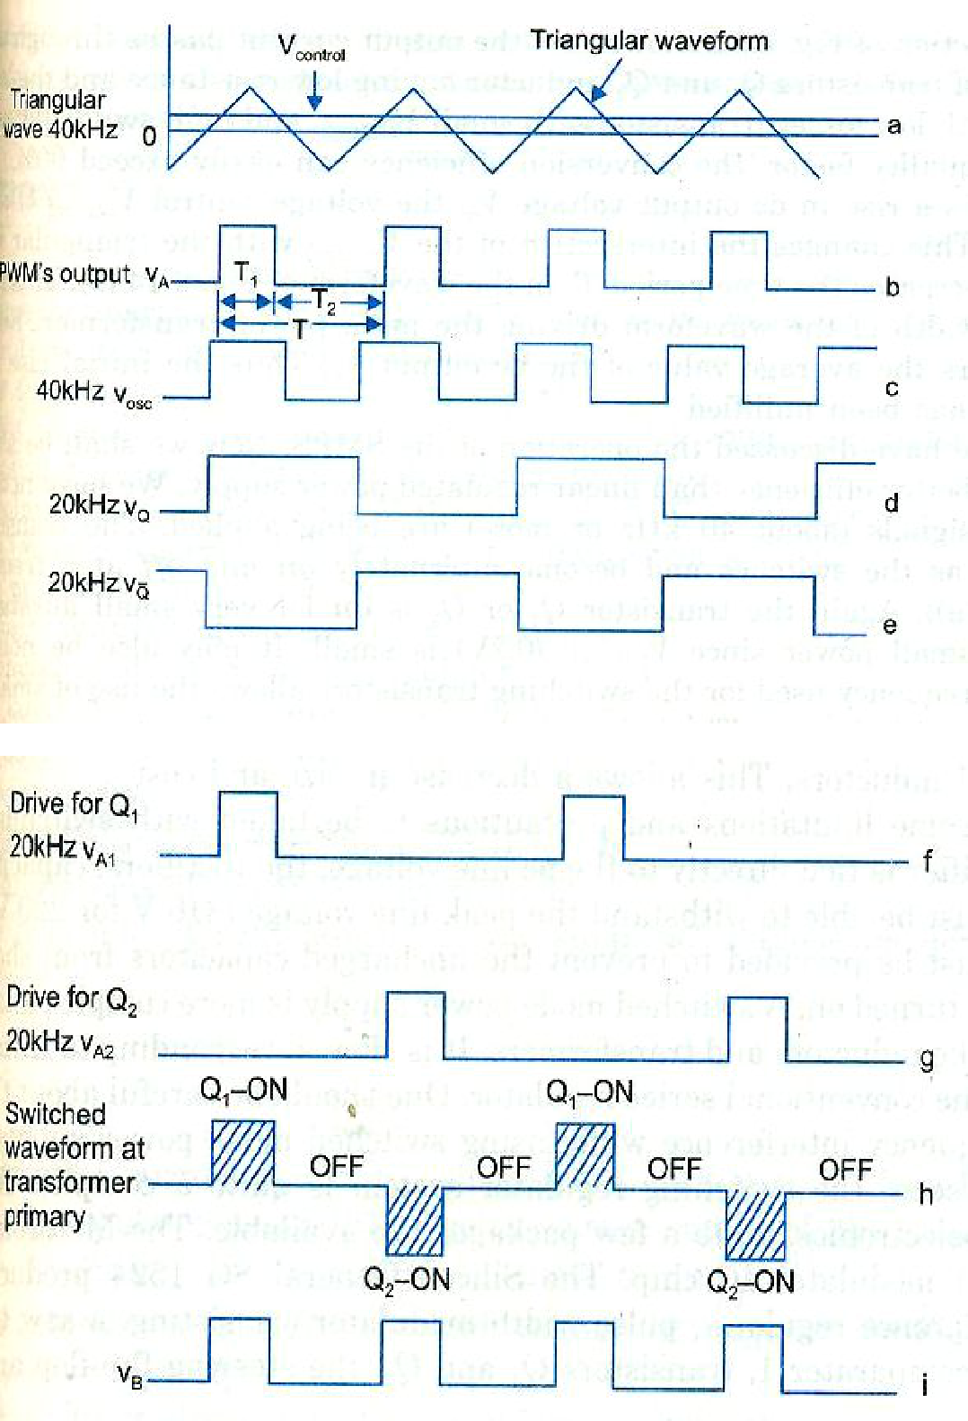

Fig : Switching power supply waveform

- The comparator 2 functions as a pulse width modulator and its output is a square wave V_{A} of period T(f = 40kHz).The duty cycle of the square wave is T₁/(T₁+T₂)and varies with V_{control} which in turn varies with the variation of V_{O}.
- The output V_{A1} drives a steering logic circuit shown in the dashed block It consist of

a 40kHz oscillator cascaded with a flip-flop to produce two complementary outputs

V_{Q} and V_{Q} The output V_{A1} andV_{A2} of AND gates A₁ and A₂ .

- Depending upon whether transistor Q₁ or Q₂ is ON, the waveform at the input of the transformer will be a square wave the rectified output V_{B .}

- If there is a rise in d.c output voltage V_{o}, the voltage control, V_{control} of the comparator 1 also rises. This changes the intersection of the V_{control} with the triangular waveform and in this case decreases the time period T₁ in the waveform

- This in turn decreases the pulse width of the waveform driving the main power

transformer. Reduction in the pulse width lowers the average value of the d.c output V_{O}, Thus the initial rise in the d.c output voltage V_{O} has been nullified.

ADVANTAGES:

- The high operation frequency used for the switching transistor allows the use of smaller transformers, capacitors and inductors.

- Due to these the size and the cost has decrease

DISADVANTAGES:

- Since the rectifier is tied directly to the ac line voltage, the rectifiers, capacitors and switching transistors must be able to withstand the peak line voltage.
7.With a neat diagram explain the operation of LM 380 Power Audio Amplifiers. (April/May-16,17,18,19),(Nov/Dec-14,16,17,19)

- Industrially standard Op-Amps such 741 can deliver abut 100mW of power with no additional external components.

- National Semiconductor produces two popular IC audio power amplifiers LM380 and LM384. The LM380 is designed to deliver 2.5W (r.m.s) to a capacitively coupled 8 load whereas LM384 can deliver 5W power and both are available in DIP packages.

- A copper lead frame is used with the central three pins (3, 4, 5, 10, 11, and 12) on either side of the DIP package forms the heat sink. Thus there is no need to separate heat sink.

- The IC can be used in inverting and non-inverting configurations. The inverting terminal can be either shorted to ground, left open or returned to ground through a capacitor or a resistor.
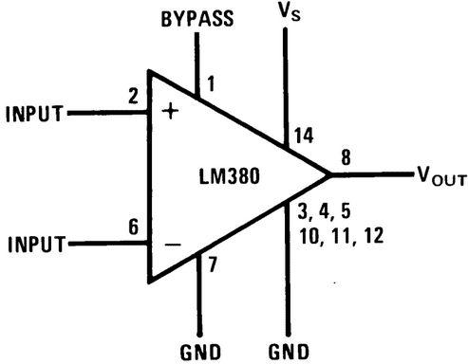

Fig: Block diagram

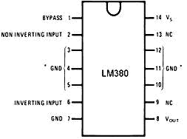

- The capacitor C₂ is used to cancel the effects of the inductance in the power supply leads. A lag compensating RC network must be connected from output to ground to avoid oscillations.

- The gain of the LM380 is internally fixed at 50 but it is possible to get he gain increased up to 300, using positive feedback as shown in the above figure.

- LM384 has the same connection diagram as that of LM380 except that it is designed to deliver 5W of power.

- There are also available hybrid power amplifiers which supply more output power than is possible using monolithic power ICs.

- Some examples are Intersil’s ICH8510/8520/8530 and Burr Brown’s 3573. The 3573

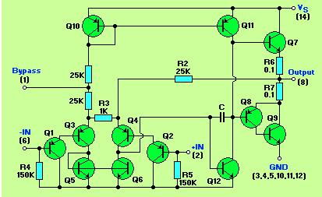
is designed to deliver 100W peak or 40W continuous output power and can be used to drive d.c and a.c motors, electronic valves and push-pull solenoids.
- Explain the working principle of IC 8038 function generator. (April/May-19,17, 16, 15) (Nov/Dec-19,17, 16)
The operation of ICL 8038 is based on charging and discharging of a grounded capacitor C, whose charging discharging rates on controlled by programmable current generates I_{A} and I_{B}, respectively. When switch is at position A, the capacitor charges at a rate determinate by current source I_{A.} once the capacitor voltage reaches V_{UT}, the upper comparator (CMP1) triggers and reset the a flip flop output. This causes the switch position to change from A to B. now, capacitor starts discharging at the rate determinate by the current sink I_{B.}
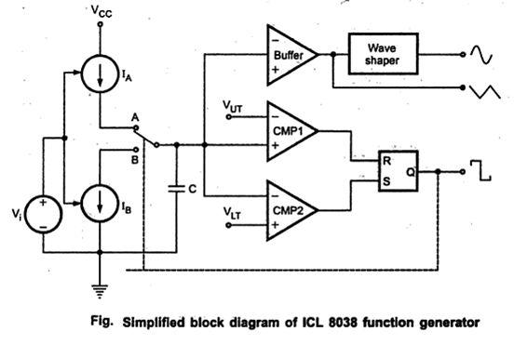

Once the capacitor reaches V_{LT,} the lower comparator (CMP2) triggers and sets the flip flop output. This causes the switch position to change from B to A. and this cycle repeats. As a result, we get square wave at the output flip flop and triangular wave
across a capacitor. The triangular wave then passed through the on chip eave shaper to generate sine wave. To allow automatic frequency control, currents I_{A} and I_{B} are made programmable through an external control voltage Vi. For equal magnitudes of I_{A} and I_{B,} output waveform symmetrically conversely, when to currents are unequal, output waveforms are unsymmetrical. By making one of the currents much larger than we can get saw tooth waveform across capacitor and rectangular wave at the output of flip flop.

CIRCUIT DIAGRAM

The transistor Q1 and Q2 from programmable current sources whose magnitudes are set by external resistors R_{A} and R_{B..}These current sources are driven by the emitter follower (transistor Q3).

It also compensate base emitter voltage for Q1 and Q2 to ensure V_{RA}=V_{RB}=V_{i}. Thus I_{A}=V_{i}/R_{A} and I_{B}=V_{i}/R_{B}. the current I_{A} controls the charging rate of capacitor C. the current I_{B} is diverted to current mirror (Q4-Q5-Q6), where it undergoes polarity reversal as well as amplification by 2 due to the combined action of Q5 and Q6. The result is a current sink of magnitude of 2 I_{B} shown in figure.

The voltage across capacitor is applied to the Schmitt trigger. The Schmitt trigger shown in figure is similar that of the IC 555, with V_{UT} =2/3 Vcc and V_{LT} =1/3 Vcc. Transistor Q7 acts a switch. When output of flip-flop high, Q7 saturates and pulls the bases of Q5 and Q6 low, thus shutting of current sink. As a result capacitor C starts charging at a rate set by a current I_{A}.

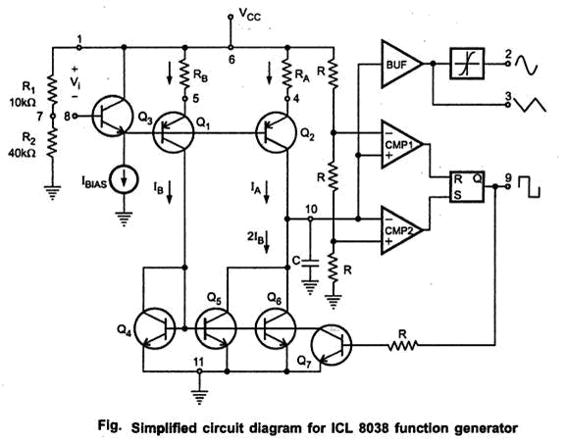
Once the capacitor voltage reaches 2/3 Vcc (V_{UT}), CMT1 triggers and clears the flip flops, thus turning Q7 off. This enables the current mirror to sink current equal to 2 I_{B} so that net current flowing out of the capacitor is I_{L} = 2I_{B}-I_{A} .

This causes capacitor to discharge. Once capacitor voltage reaches 1/3 Vcc (V_{LT}), CMP2 triggers and sets the flip-flop and action repeats. It is important to note that net current flowing out of capacitor C should be positive i.e 2 I_{B}-I_{A} > 0 discharging capacitor and hence 2 I_{B} > I_{A .}

